Reliability and Safety Analysis

Year: 2023 Semester: Spring Team: 8 Project: Engineer’s Chess

Creation Date: March 28, 2023 Last Modified: April 1, 2023

Author: Jack Gardel Email: [jgardel@purdue.edu](mailto:jgardel@purdue.edu)

1. Reliability Analysis

All components listed below have the same calculations for failure rate (λP) and MTTF, which are based on the “microelectronic circuit” section:

λP = (C1 * πT + C2 * πe) * πl * πq

Values for all components were found in the military handbook [1] in conjunction with the corresponding datasheets. Additionally, the quality factor is assumed to be 10 for all components, as they are all of commercial make. The temperature coefficient is always assumed to be the max temperature of the device and the environmental constant is “grounded-benign” because we do not expect this product to move very much once it is placed on a table.

STM32F091RCT6

The STM32 [2] is our primary computational unit that we solder onto the board; if it fails the project will not have any functionality as it connects all user I/O to the Jetson Nano (with the exception of audio input). A failure of this device would not be dangerous to the user but would render the product unusable.

| Parameter name | Description | Value | *Comments* |
| --- | --- | --- | --- |
| C1 | Die complexity | 0.52 | 32-bit microcontroller |
| πT | Temperature coeff. | 5.6 | 150C Tmax CMOS |
| C2 | Pin/package const | 0.032 | 64-pin SMT |
| πe | Environmental const | 0.5 | Grounded-benign |
| πl | Learning factor | 1.0 | > 2 years in production |
| πq | Quality factor | 10.0 | Commercial |
| Entire design: |  |  |  |
| λP | Failure rate | 29.28 | failures per 106 hours |
| MTTF | Mean time to failure | 0.0342 | 106 hours |

LD1117

The LD1117 [3] is the voltage regulator shifting 5V to 3.3V. The components that use 3.3V are the buttons, OLED displays, and most importantly the STM32 making this voltage regulator a critical path component. Failure of this component would most likely not cause harm except in the case of a short.

| Parameter name | Description | Value | *Comments* |
| --- | --- | --- | --- |
| C1 | Die complexity | 0.01 | 1 to 100 BJT |
| πT | Temperature coeff. | 58 | 125C Bipolar |
| C2 | Pin/package const | 0.0012 | 3 functional pins |
| πe | Environmental const | 0.5 | Grounded-benign |
| πl | Learning factor | 1.0 | > 2 years in production |
| πq | Quality factor | 10.0 | Commercial |
| Entire design: |  |  |  |
| λP | Failure rate | 5.806 | failures per 106 hours |
| MTTF | Mean time to failure | 0.172 | 106 hours |

CD40109B

This is a level shifter [4] that appears 5 times on our board and is responsible for interfacing with the main display. The higher quantity of this IC plus the larger pin count makes it worthy for a reliability analysis. Like the other two components, failure of the level shifter would not cause harm to the user but would render the product less useful.

| Parameter name | Description | Value | *Comments* |
| --- | --- | --- | --- |
| C1 | Die complexity | 0.01 | 1 to 100 CMOS |
| πT | Temperature coeff. | 3.1 | 125C Tmax CMOS |
| C2 | Pin/package const | 0.0072 | 16-pin SMT |
| πe | Environmental const | 0.5 | Grounded-benign |
| πl | Learning factor | 1.0 | > 2 years in production |
| πq | Quality factor | 10.0 | Commercial |
| Entire design: |  |  |  |
| λP | Failure rate | 0.346 | failures per 106 hours |
| MTTF | Mean time to failure | 2.89 | 106 hours |

Summary

The level shifter has a relatively low failure rate, and is a good choice for the design. The voltage regulator has a higher failure rate which could be solved by a more robust regulator (i.e. switching regulator over linear). The failure rate for the microcontroller is very high due to the maximum temperature being 150C. Earlier, an assumption was made that this device would operate at the worst-case temperature, however we may be able to relax this assumption given that the STM32 microcontroller never reaches that temperature range. If the STM32 does get hot, a lower-power microcontroller may be necessary for future designs.

1. Failure Mode, Effects, and Criticality Analysis (FMECA)

The highest level of criticality for this section corresponds to a failure rate of λ > 10-10, just below what would be dangerous for a user. A medium level of criticality would cease operation of the device, and the failure rate would be λ < 10-10. A low level of criticality implies that the user is inconvenienced by the failure with a failure rate of λ < 10-11. Our assumption is that our product will lay flat on a table inside for most of its operation.

3.0 Sources Cited:

* [1] “Military Handbook” 1990 [Online] Available: <http://snebulos.mit.edu/projects/reference/MIL-STD/MIL-HDBK-217F-Notice2.pdf>
* [2] STM32F091xB/STM32F091xC Datasheet [Online] Available: <https://engineering.purdue.edu/477grp8/Files/refs/STM32F091xB_STM32F091xC%20Datasheet.pdf>
* [3] LD1117 Datasheet [Online] Available: <https://engineering.purdue.edu/477grp8/Files/refs/Voltage_Regulator.pdf>
* [4] CD40109B Datasheet [Online] Available: <https://engineering.purdue.edu/477grp8/Files/refs/Level_Shifter_cd40109b.pdf>

Appendix A: Schematic Functional Blocks

Power Subsystem

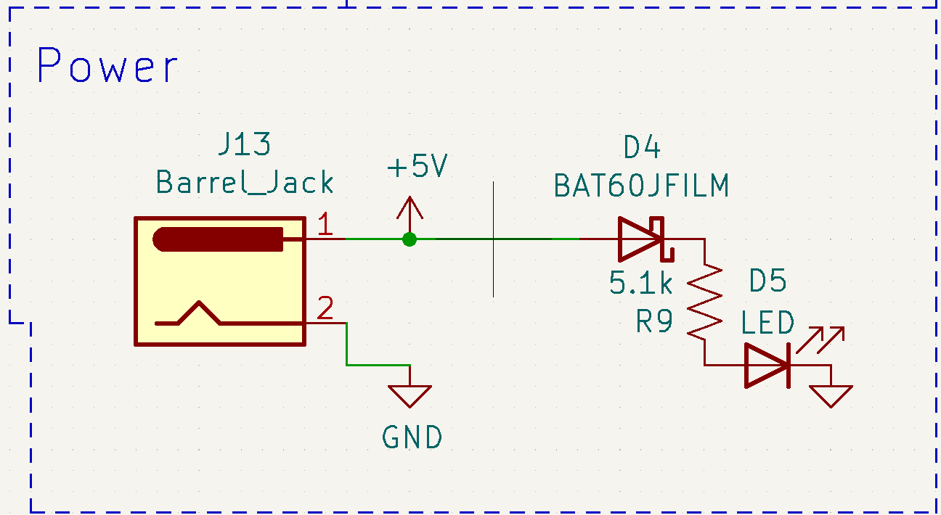

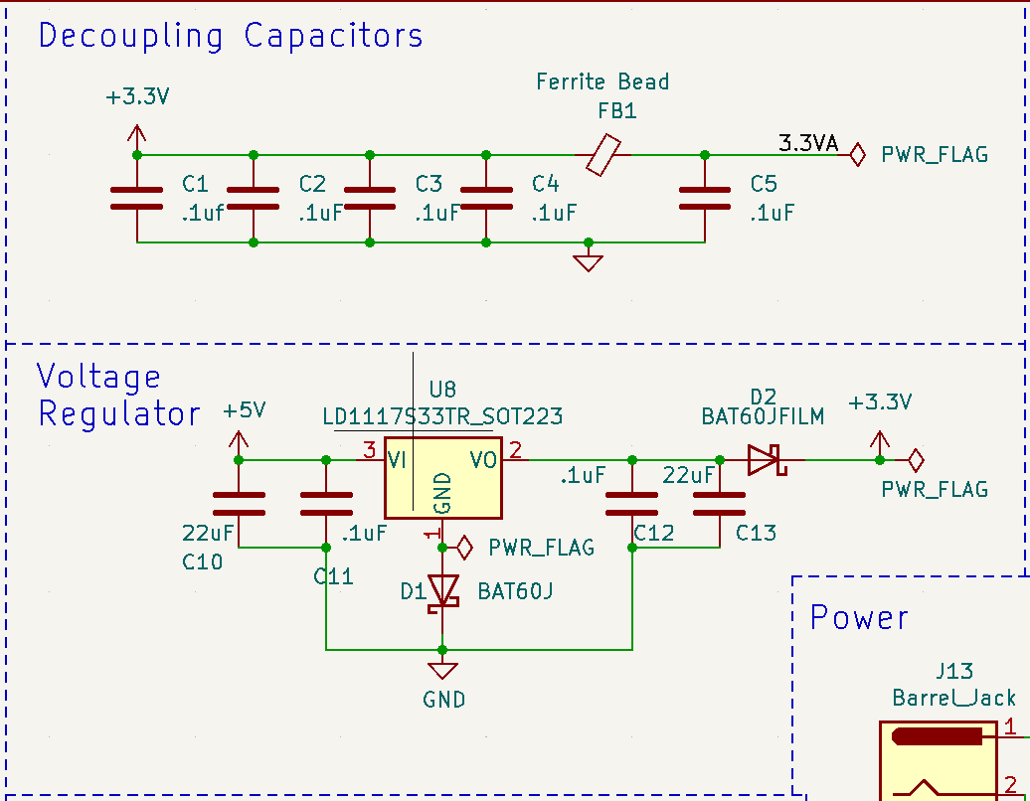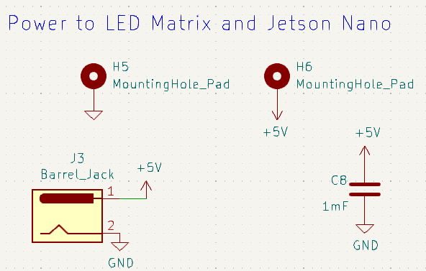

Microcontroller Subsystem

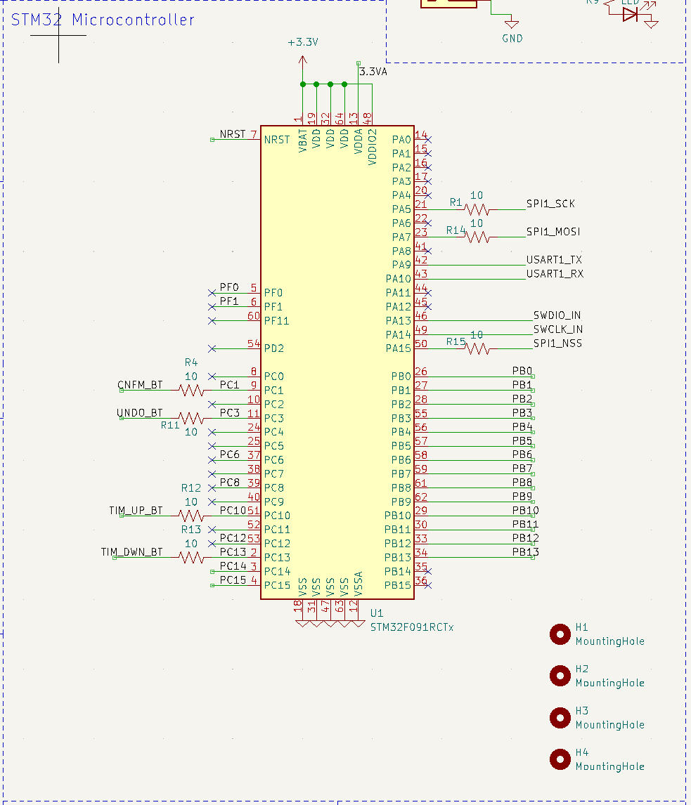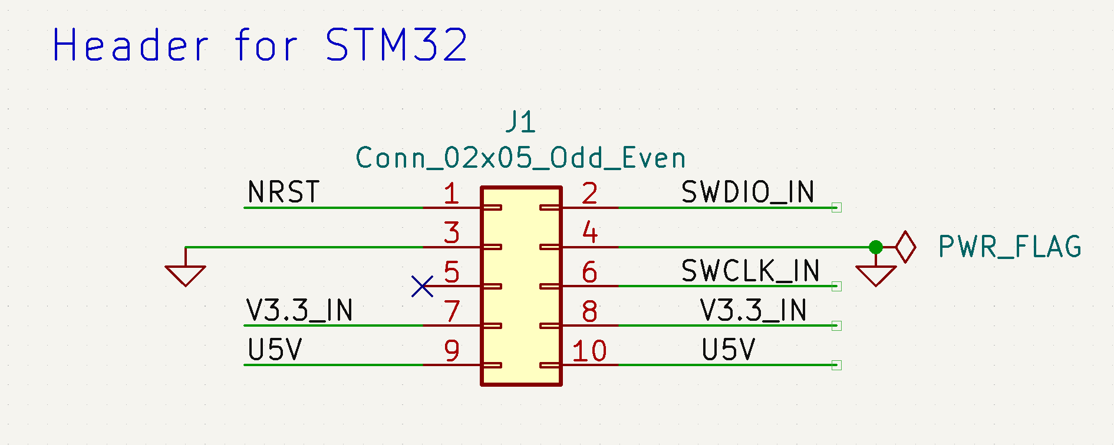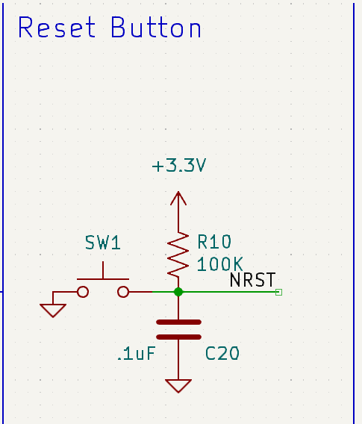

LED Matrix Subsystem

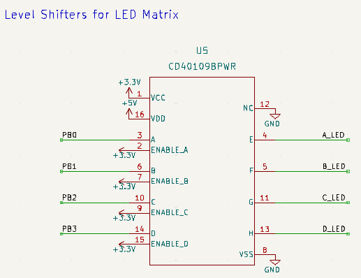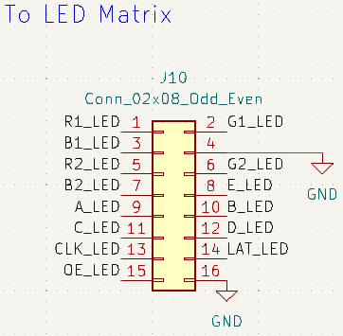

Header Subsystem

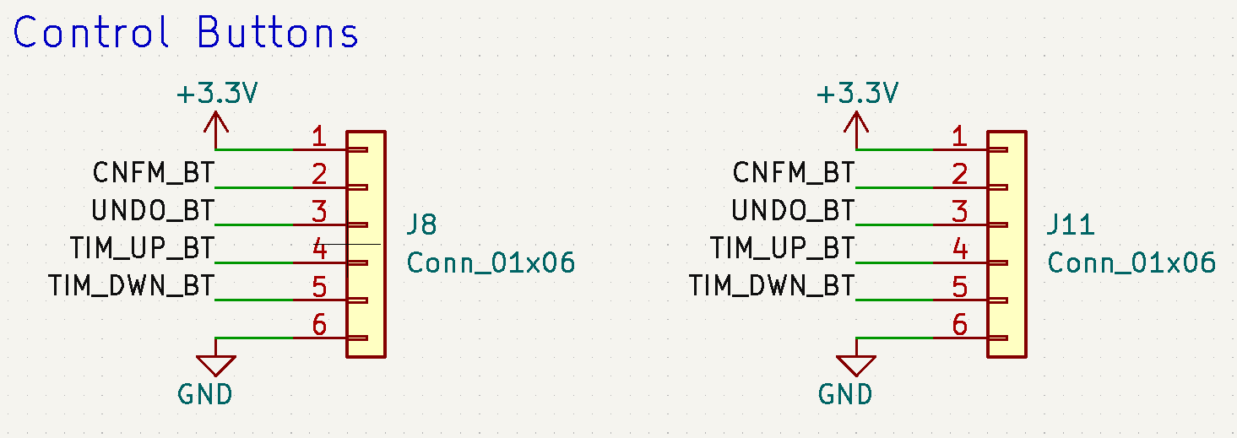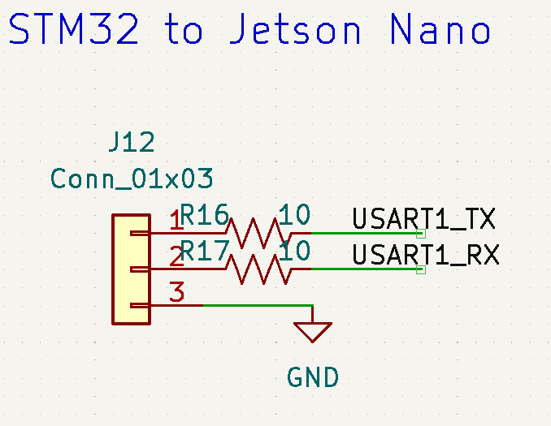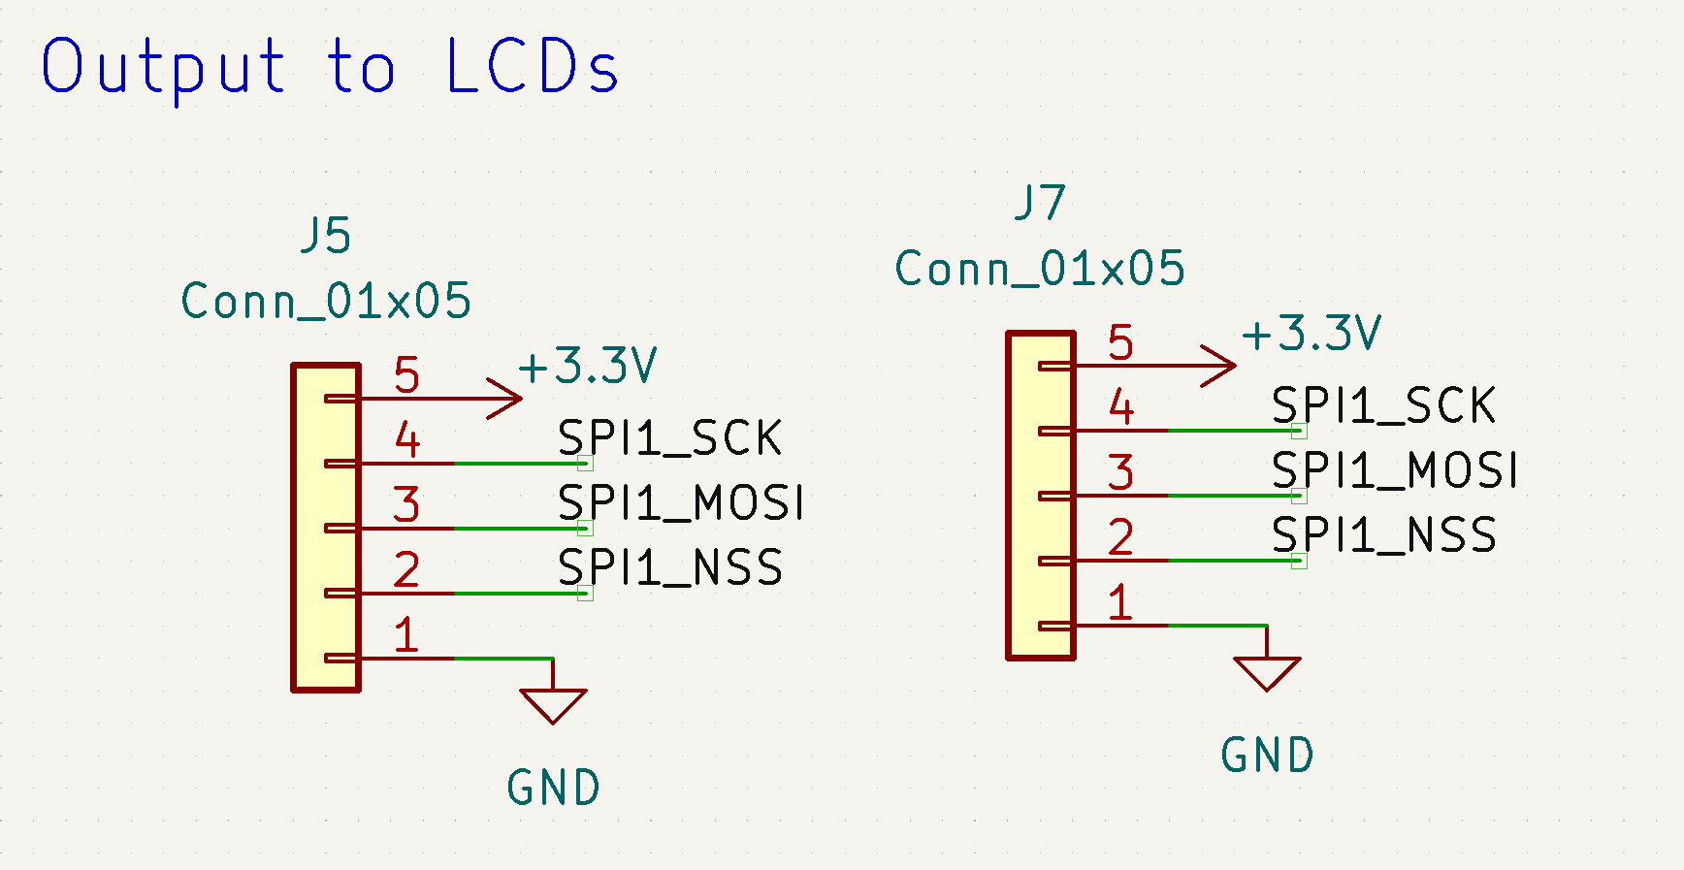

Audio Subsystem

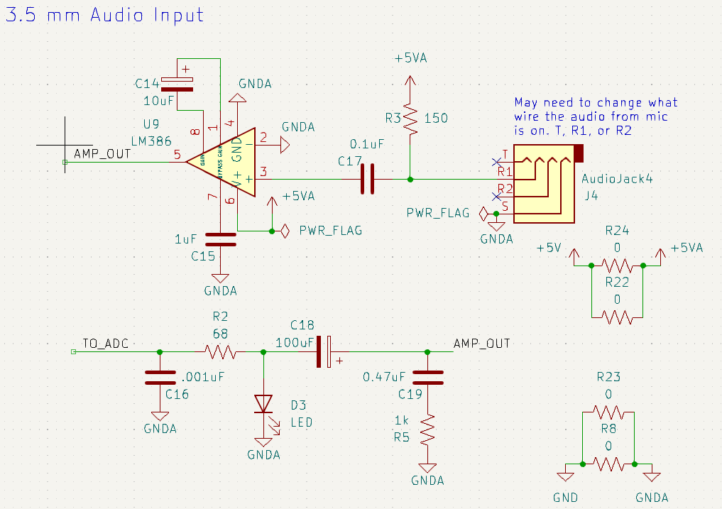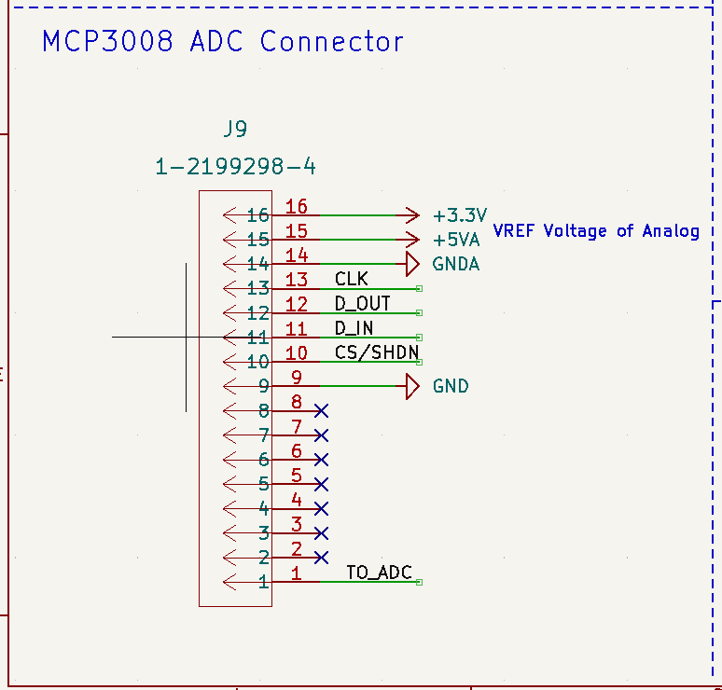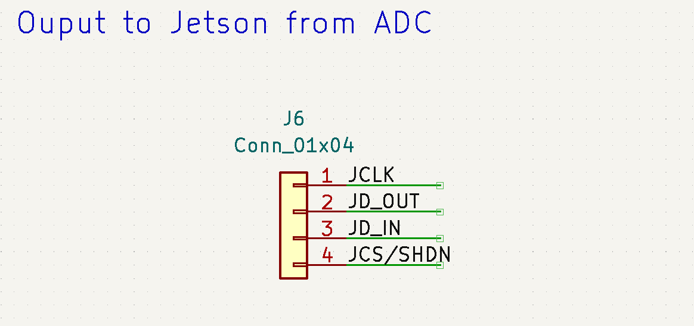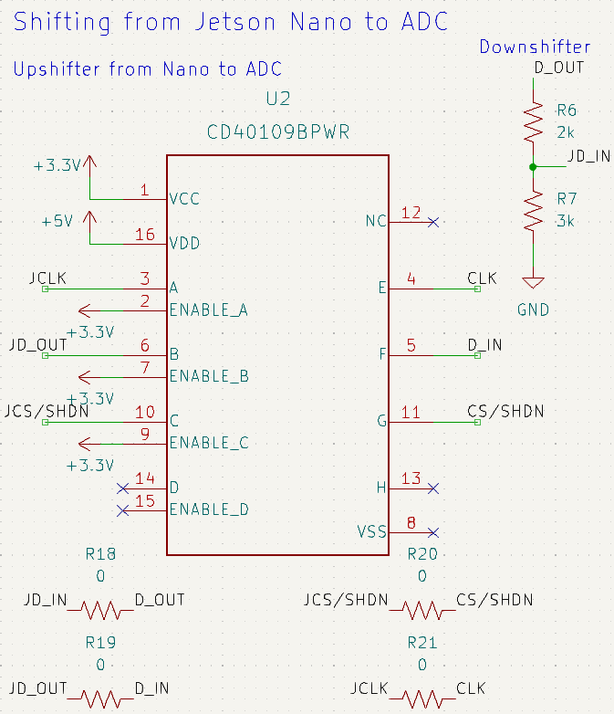

Button Subsystem

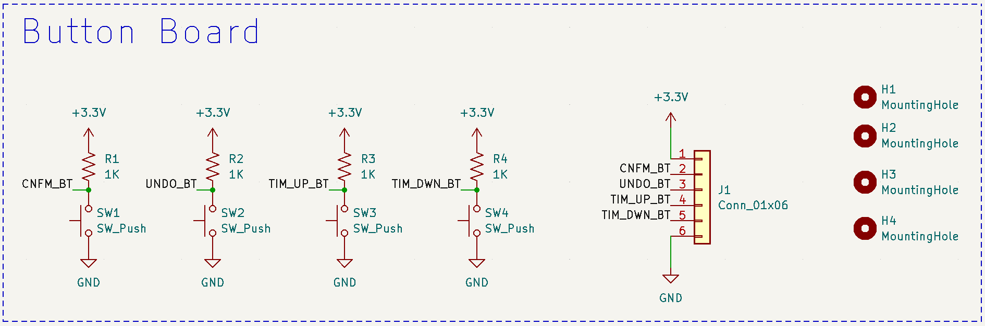

Appendix B: FMECA Worksheet

Power Subsystem

| **Failure No.** | **Failure Mode** | **Possible Causes** | **Failure Effects** | **Method of Detection** | **Criticality** | **Remarks** |
| --- | --- | --- | --- | --- | --- | --- |
| 1 | Voltage regulator failure | Shorted capacitor, faulty regulator, overheated regulator | Microcontroller gets no power, OLED display doesn’t display anything | Observation | High | Device unusable, potential harm to user given this is a regulating component. |
| 2 | Voltage dropping below 3V on the regulator | Unexpected current draw, popped or shorted capacitor (C10-13) | Microcontroller brown out | Voltmeter | Medium | Device unusable |
| 3 | Large decoupling capacitor failure | Off-board transformer has a power surge the capacitor can’t handle | Overloading of LED matrix and Jetson Nano | Observation | High | Potential risk to user when such a large capacitor fails |
| 4 | Diode failure | D1, D4, D5 | Improper regulator output, LED not working | Multimeter | Low | Microcontroller more susceptible to brown-out but may still work |

Microcontroller Subsystem

| **Failure No.** | **Failure Mode** | **Possible Causes** | **Failure Effects** | **Method of Detection** | **Criticality** | **Remarks** |
| --- | --- | --- | --- | --- | --- | --- |
| 5 | Microcontroller stops execution | Unexpected path of execution or input sequence | Unresponsiveness of the game until reset | Observation | Low | Assuming this is not due to any physical damage |
| 6 | Incorrect sequence received over UART | Noise or interference in TX/RX lines | Incorrect game state | Oscilloscope on TX/RX lines | Low | Can be recovered from in reset sequence or by pressing “UNDO” |
| 7 | Programming failure | Frayed ribbon cables, poor soldering | No response from the microcontroller | Observation | Medium | Product unusable unless taken apart and reprogrammed |
| 8 | Decoupling capacitor popping/ failing | Excessive heat, poor-quality component | Corrosion of microcontroller area | Observation of PCB | High | Potential risk to user, could get hot and burn the wood casing |

LED Matrix Subsystem

| **Failure No.** | **Failure Mode** | **Possible Causes** | **Failure Effects** | **Method of Detection** | **Criticality** | **Remarks** |
| --- | --- | --- | --- | --- | --- | --- |
| 9 | LEDs on matrix not lighting up | Burnt out LED, damaged protocol line, poor soldering of the header | Limited or no main display | Observation | Low |  |
| 10 | Level shifter failure | Poor-quality part, bad soldering (overheated pads) | Poor communication with main display | Observation | Low |  |

Header Subsystem

| **Failure No.** | **Failure Mode** | **Possible Causes** | **Failure Effects** | **Method of Detection** | **Criticality** | **Remarks** |
| --- | --- | --- | --- | --- | --- | --- |
| 11 | Poor communication with peripherals | Poor soldering of the headers | No response from the buttons, OLED display failure, game-state failure | Observation | Medium | Poor soldering would affect all packets going across peripheral lines, unusable product |

Audio Subsystem

| **Failure No.** | **Failure Mode** | **Possible Causes** | **Failure Effects** | **Method of Detection** | **Criticality** | **Remarks** |
| --- | --- | --- | --- | --- | --- | --- |
| 12 | Incorrect voice recognition | EMI in analog circuitry, noisy environment, failed components (capacitors C14-19) | Game cannot progress | Observation | Medium |  |
| 13 | Voice input too loud | Audio input too close to mic, microphone with amplification built-in | Shorting of test LED, damage to op-amp, possible incorrect voice recognition | Oscilloscope | Low | User can fix this by getting a different microphone or by moving away from the mic |

Button Subsystem

| **Failure No.** | **Failure Mode** | **Possible Causes** | **Failure Effects** | **Method of Detection** | **Criticality** | **Remarks** |
| --- | --- | --- | --- | --- | --- | --- |
| 14 | Button breaks | Pushing too hard, button not soldered correctly | Delayed or no input | Observation | Medium |  |